Tuesdays beginning January 6th
@ 5:30 in the Fellowship Hall
College & Career: Rooted & Rising
Chili Supper & Begin Study

Prayer Boot Camp: The Battle Plan for Prayer
Ages 18 & up
January 9th 6:00-8:30 Dinner Provided
January 10th 8:00-12:00 Light Breakfast
Childcare is available – indicate on registration form
Register by January 2nd online or in the office
Cost $20, pay in the office by Monday, January 6th


January 11th @ 5:00

Small Groups Winter/Spring
January 18 – April 19
- Mark McCutcheon/Jim Sanford: A study on the morning’s sermon in Acts.
- Charlie Horton, Terrell & Stacy Haggerty A Study through the Book of James
- Michele Kuykendall & Lauren Rawls
Tim Keller’s Prodigal God
- Greg Sanders: A study on the Book of Romans

TEDDY BEAR MISSION PROJECT
January-March
TEDDY BEARS ONLY: NEW 10”-12”
You may donate money or teddy bears.
Questions: Ann Atkins 256-825-6866

DECISION-INFORMATION
(Complete Contact information on the
other side and check all that apply.)
- I’m making a first-time commitment to Christ.
- I am renewing my commitment to Christ.
- I want to find out about baptism.
- I want to become a member of the church.
- I want to join a Bible study.
- I want to commit my life to full-time Christian service.
- I want to commit my life to full-time missions.
- I want to serve where needed.

I would like information on:
- How to become a Christian
- How to join the church
- Family Activities
- Adult Ministries
- Single Adult Ministries
- Student Ministries
- Preschool/Children ministries
- Music and worship ministries
- Other ________________________

Requests
- I would like to speak with a minister.
- I would like more information on the church.
- Prayer Requests and other needs:
____________________________
____________________________
____________________________
____________________________
____________________________
____________________________
____________________________
____________________________

Name _________________________
Phone _________________________

The Unstoppable Church: An Attitude Of Obedience
Acts 5:17-32

The P__________________ Of Obedience

· E___________ obeys s____________ .

· Obedience always r___________ a c___________ .

· Obedience u_____________ God’s p___________

The C___________ Of Obedience.

· Obedience may cost you your f____________ .

· Obedience may cost you your s_______ and r__________ .

· Obedience does not guarantee c________ ; it guarantees God’s p_______ .

The P_____________Of Obedience

· God w__________ when His people o_________ .

· Obedience brings the p________ of the H______ S_________ .

· Obedience p_________ c___________ .

The P____________ Of Obedience

· God often w_________ s__________ on p_________ .

· Obedience is c_________ : s_______ by s_______ , d_____ after d_____ .

· Obedience doesn’t s_____ a__________ from the w_________ .

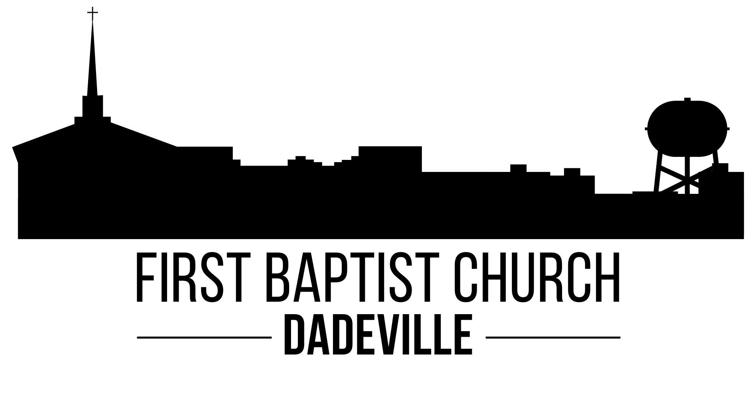
SUNDAY MORNING 8:30 & 11:00 January 4, 2026
Prelude
Welcome and Prayer Dr. Ben Hayes
Opening Celebration
Congregation Revive Us Again
Gratitude
Prayer
In Christ Alone
Worthy of Worship
Children’s Message
Message in Song
Message The Unstoppable Church:
An Attitude Of Obedience Dr. Ben Hayes
Acts 5:17-32
Invitation Wherever He Leads I’ll Go
He Is Lord

Children’s Worship Activity Kits are available in the foyer.
Children’s Church for Pre-K through 2nd grade after Children’s Message

Sunday School 9:45

NO SUNDAY EVENING ACTIVITIES

WEDNESDAY ACTIVITIES January 7, 2026
10:00 Men’s Bible Study Bro. Ben Pat White Classroom
Women’s Bible Study on Ruth begins Jan. 21st (Nanci Speagle)
Sign up in the office by Jan. 11
4:45 Wednesday Supper: Taco Salad, Chocolate Pudding
5:45 Prayer Meeting and Bible Study – Pat White Classroom
Activities for Kids & Youth
7:00 Choir Rehearsal

Monthly Budget Needs $93,676.33
Receipts for December $76,742.76
Receipts for Vision 2026 $1,489,123.61
Lottie Moon $11,810.00

To Gather for Worship Online
LiveStream: www.fbcdadeville.com/live-stream
www.facebook.com/FirstBaptistChurchDadeville/
Youtube: https://youtu.be/NofBYNG8qkQ

January 4-10 Greg Sanders: Hospital Visitation Wednesday
January 11-17 Charlie Kuykendall: Hospital Visitation Thursday
January 18-24 Dr. Ben Hayes: Hospital Visitation Monday
January 25-31 Hunter Baker: Hospital Visitation Tuesday
Pastor on Call Hospital Visitation Friday, Saturday & Sunday

First Baptist Church Dadeville
Mailing: PO Box 308 Dadeville 36853
178 Tallassee St. 256-825-6232
Email: office@fbcdadeville.com web: fbcdadeville.com
Senior Pastor: Dr. Ben Hayes bhayes@fbcdadeville.com
Minister of Music & Sr. Adults: Charlie Kuykendall charlie@fbcdadeville.com
Music Technologist: Austin Glass aglass@fbcdadeville.com
Minister of Children & Families: Greg Sanders gsanders@fbcdadeville.com
Minister of Youth: Hunter Baker hbaker@fbcdadeville.com
Secretary office@fbcdadeville.com
Financial Secretary fbcdadeville@gmail.com
Deacon Chairman: Max Graham

WELCOME Date: _________
Tell us more about you!

Name(s) __________________________
_________________________________
Address __________________________
_________________________________
City _____________________________
State ______________ ZIP __________
Phone ___________________________
Phone (cell) ______________________
Email ___________________________
Please contact me by
☐ U.S. Mail ☐ Phone ☐ Email
First Visit to our church? ☐ Yes ☐ No
Member of a Church? ☐ Yes ☐ No
Church Name _____________________
_________________________________
City, State ________________________
Guest of __________________________

Circle all ages or grades visiting:
Preschool: 0 1 2 3 4 5
Children: K 1 2 3 4 5
Students: 6 7 8 9 10 11 12
Adults: 18-24 25-34 35-44
45-54 55-64 65-74 75+

How did you learn about our church?
☐ Friend ☐ Mailing ☐ Newspaper
☐ Internet ☐ Other ________________
New to the Community ☐ Yes ☐ No
Comments: _______________________
_________________________________
_________________________________

